

## [**Recruitment**](http://en.wikipedia.org/wiki/Recruitment) **System**

## **For**

## [**Inova IT Systems (Pvt) Ltd.**](http://www.inovaitsys.com/)

Project Proposal

Information Technology final project

Project ID: HDCS 2013/14FT-NU-04

Submitted by:

Submitted to:

…………………………..

Mr.

15/09/ 2014

# Abstract

This project is for a POS system. We are making this project for the Rajaguru Stores [pvt] Ltd. It is a grocery shop which is focusing to supply customer requirements using an online system and a POS system.

So we met the Rajaguru Stores owner Mr.Sudath Rajaguru and suggested him to purchase our POS System. So we are working together as a team to complete our task and we are hoping to fulfill the client requirements with the support of our suggestions. We are mainly targeting to satisfy our client and make the software which our client actually expects.

# Contents

1. Introduction and Description of the Project ……………………………………………………….3
   1. Problem Specification………………………………………………………………………...3
   2. Solution Outline………………………………………………………………………………4

1.2.1 Collect curricula vitae…………………………………………………………………....5

1.2.2 Employee privileges……………………………………………………………………..5

1.2.3 Security………………………………………………………………………………......6

* + 1. Criteria checking system ………………………………………………………………..7
    2. Interview data handling system………………………………………………………….7
    3. Candidate changing system……………………………………………………………...9
    4. Time wastage ……………………………………………………………………………10
  1. Key benefits…………………………………………………………………………………….10

2. Objectives………………………………………………………………………………………….11

2.1 Login System ………………………………………………………………………………....11

2.2 Candidate System …………… ………………………………………………………………..11

2.3 Criteria checking System ……………………………………………………………………..12

2.4 Interview Data Handling System….………………………………………………………….12

2.5 Candidate Changing System….………………………………………………………………..12

3. Procedures....................................................................................................................................13

3.1 Flow of the Project…………………………………………………………………………...13

3.1.1 Feasibility Study………………………………………………………………….…...13

3.1.2 Requirement Analysis…………………………………………………………………13

3.1.3 System Analysis……………………………………………………………………….14

3.1.4 System Design…………………………………………………………………………14

3.1.5 Implementation and Unit Testing……………………………………………………...15

3.2 Project Plan……………………………………………………………………………...........16

4. Personnel and Facilities……………………………………………………………………......17

5. Hardware and Software Requirements………………………………………………………….18

5.1 Hardware Requirements ………………………………………………………………18

5.2 Basic System Requirements…………………………………………………………..18

5.3 Software Requirements………………………………………………………………..18

6. Budget …………………………………………………………………………………………19

7. Reference……………………………………………………………………………………….20

1. **Introduction and Description of the Project**

Our goal is to develop a POS System for Rajaguru Stores (Pvt) Ltd. According to our observation reports, we have found several significant functions.

This system is specifically going to be developed as a POS System for the above mentioned process. In this process, the Store items are stored in the stock control system. Then the new items are added and the current items are reduced from the system when transactions are done. Once the transaction system and the stock control system are created, then the billing system is created. We are also making an online system for this system.

* 1. **Problem Specification**

Our main purpose is to satisfy the client requirements such as efficiency, speed and accuracy of the day to day transactions within the system. These are the client problems that we targeted to resolve.

* To manage the billing and store items since the count of the items increase.
* To find the quantity of sold items and the profit of them.
* To determine the change in the quantity of the store item.
* To summarize the Expenditure, Profit and Loss.
* More time to make the project.
  1. **Solution Outline**

We have given you a brief idea in above problem specification, and in this part we suppose to explain how we are going to achieve our final target during the scheduled period maintaining all the goals and objectives mentioned in the project.

**** Rupasatahana****

* 1. **Key benefits**

Main benefits of our software are,

* Information security
* Data storage system
* Time is saved, increase in transaction Speed and make the work easy.
* Profit increase

Can make count of the amount of work done

1. **Objectives**

* Our goal is to satisfy the client’s requirements to the maximum.
* Our intension is to give efficient and productive, client friendly system.
* To limit the errors within the manual system.
* To give reliable information about data and maximum security for the database where data within the system cannot be access by any third party.
* To aware the client about the items that is out of stock. Also to warn about the expired items.
* To do many transactions within a short time.
* To indicate the profit, loss, expenditure, special offer, discounts, within the store.

**2.1 Billing System**

Billing part is a major part of a grocery and it interacts with all daily transactions. In this system we suppose to provide chance to get a printed bill included of all necessary facts according to client’s requirements such as bought items, quantity of each, price of each and total price, Discounts. A printer connects to the machine and people who handle the system can enter all above values manually and can print the bill from a single command

**2.2 Stock Handling System**

Stock Handling is also an important part in the system. All items will be recorded when they accepting from the stock manager. For every transaction System’s database will be update and if some item decreases than minimum number of the certain item the system informs that from a message. Our client don’t want to exist any expired items in the stock, so that we created a notification prompt for stock keeper with expired item’s name and quantity remaining when an item expired.

**2.3 Suppliers Details**

There is an aspect of the system to store information about the suppliers, what are the equipment they supply, quantity and expire date. And also client requires a section to manipulate information of employees like salary and working hours.

* 1. **Online System**

We are supposed to create an online system which customers can buy goods through an online system. For this the customer has to register in our online system and order the items and give the delivery time where customer wants the order to be delivered. Delivery charge may apply according to the distance.

**3. Procedures**

**3.1 Flow of the Project**

Through a contact, the project team was able to make an appointment to discuss with the Director of Rajaguru Stores (Pvt) Ltd. There he explained that they have a problem with manipulating information in their large stock handling system as they did not have any automated system which is specific to the company.

So our team got their requirements and planned to do our first project well. We are mainly targeting to satisfy our client and make what actually client requires.

**3.1.1 Feasibility Study**

After gathering information from the client, our group members had some discussion sessions to analyze the information we have gathered and discuss about the feasibility.

• Schedule Feasibility

• Economic Feasibility

• Technical Feasibility

**3.1.2 Requirement Analysis**

We collected the requirements from the workers, client and customers. Then we analyzed the requirements step by step. Last we sent the requirement analysis report to the system analysis team.

**3.1.3 System Analysis**

As the company does not have any system it was totally a brand new task to decide a suitable system as the requirement analysis has done by studying the manual process. The basic system has been analyzed and there can be differences according to the client requests in the future.

Our next task will be developing and designing the prototype, writing the SRS document and then creating the DFD and finally preparing the ER diagram.

**3.1.4 System Design**

The design part is going to be divided into several main categories.

* + - * **Software and web interface designing**

This will be one of the most important parts in the designing part because the user is interacting with the interface which is provided, so the interface must be user friendly and must fulfill all the needs of the customers.

* **Database Designing**

Database should be well designed as there is lot of information which the customer is involved with. So the database is going to be implemented using Logical database design and Scheme refinement by applying Normalization.

**3.1.5 Implementation and Unit Testing**

We’ll be allocating functions among group members to implement those functions. After the basic functions are implemented, basically a structure and design is to be generated to get feedback from the users. After the feedback is taken, the necessary changes are to be done. Next step is to combine the functions together that are implemented by each individual group member and implement the full function for further unit testing.

After implementing the fully functional system, we are planning to do white box testing, black box testing and also the most important part; stress testing is going to be concluded.

Finally our group members suggested implementing the System for selected employees for further testing.

**3.2 Project Plan**

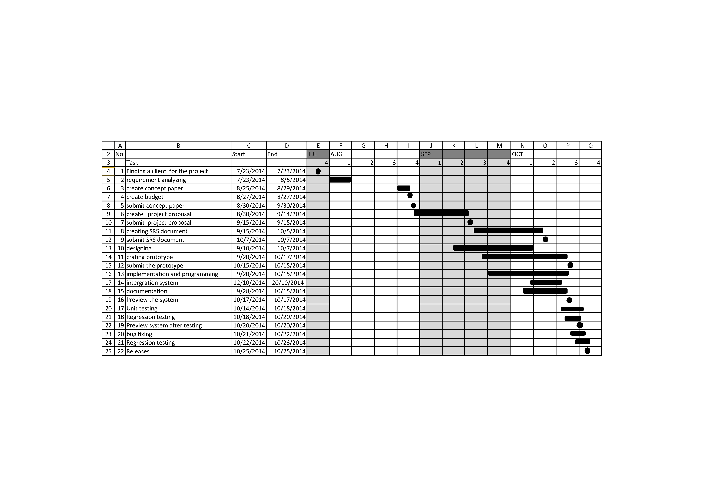

Figure 3.2: Gantt chart

**4. Personnel and Facilities**

|  |  |  |
| --- | --- | --- |
| **Student number** | **Members and roles** | **Function** |
| 13NU1217 | (SW team leader /programmer /tester/Group leader ) | **Developer**  (criteria checking system)  Database Design  Designing GUI  Coding  Documentation of the project Designing the system |
| 13NU1213 | (project manager/programmer/tester) | **Developer**  (interview data handling system)  Database Design  Designing GUI  Coding  Documentation of the project Designing the system |
| 13NU1177 | (coordinator/ programmer/tester) | **Developer**  (login system-user management)  Database Design  Designing GUI  Coding  Documentation of the project Designing the system |
| 13NU1211 | (Error handling / programmer/ tester) | **Developer**  (candidate’s system)  Database Design  Designing GUI  Coding  Documentation of the project Designing the system |
| 13NU1207 | (Documentation handling /programmer) | **Developer**  (data changing system)  Database Design  Designing GUI  Coding  Documentation of the project Designing the system |

Figure: 4. Personnel and Facilities

**5. Hardware and Software Requirements**

**5.1 Hardware Requirements**

To implement this recrutment System does not need a very high end machine. Because this system run in a web server and the user only sees the server generated HTML code which he views through a standard web browser. However broadband internet connection is suggested to gain a good performance.

**5.2 Basic System Requirement**s

1. 2.0 GHz processor with 2MB L2 cache Memory 512MB DDR II RAM Memory
2. 100 GB HDD (if necessary must expand as system request) (Other features in a pc won’t be a much issue)
3. Web server
4. System needs a web server which enables PHP, SQL, DNS server, Mail server, Security and an enough space to implement this recrutment system.

**5.3 Software Requirements**

* To run the HRM Automation System success fully in a operating system it need(Linux, Windows, Mac OS) and any kind of Browsers
* Adobe Dreamweaver CS6
* Adobe Photoshop CC
* MySql version 5.6.20
* Xampp 1.8.3-3-VC11- sever

**6. Budget**

The main expenses in this project are

• Travelling Charges

• Communication charges

• Document Preparing

• For Stationeries

And approximately these will take around Rs.5000.00 to cover up our expenses.

|  |  |
| --- | --- |
| **Description** | **Withdraw (Rs.)** |
| Travelling Charges | 1000.00 |
| Stationeries | 500.00 |
| Communication Charges | 500.00 |
| Document Preparing | 2000.00 |
| **Total** | **4000.00** |

Figure: 6.Budget

**7. References**

[1] PHP manual

www.php.net/docs.php

[2] PHP tutorials from following site.

www.w3schools.net

www.php.net

[3] General Manager of Inova IT Systems (Pvt) Ltd

[4] Library books & E-books